**Objective:** Design and Construct a **fully functioning autonomous robot** that can navigate itself through a **series of obstacles** within a defined playing grid, **capture an “enemy” flag** and finally, **return that flag** to its area of the grid.

**Specifications**

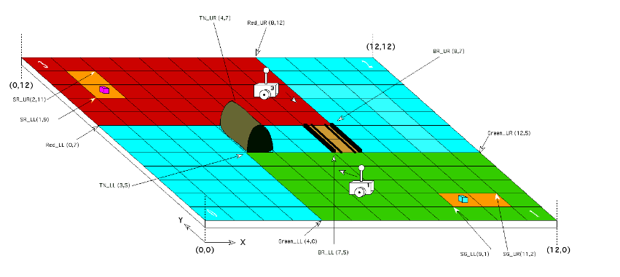

* Autonomous Robot capable of traversing a playing field and capturing an enemy flag
* The playing field measures 12 x 12 feet, with the origin located in the lower left hand corner, (0,0), as shown in Figure 1
* Blue zones indicate a river and they cannot be traversed.
* 2 key obstacles within the playing field: Tunnel and Bridge.
* The Tunnel has a width of 22.07cm and a height of 25.75cm. The bridge has a width of 26.01.

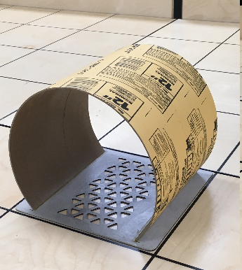 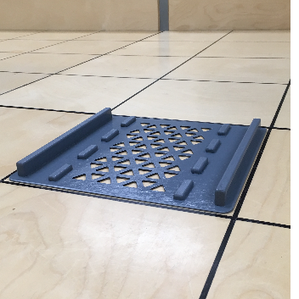

* Game Parameters and Instructions received by Wi-Fi
* Once the parameters are received each player must complete the requirements to achieve victory

**Requirements (How to Win)**

1)Receive parameters from game controller correctly

2) Localize under 30 seconds

3) Navigate to tunnel/bridge

4) Traverse river to the opposite side

5) Search for opposition flag

6) Indicate capture

7) Navigate back to the start

8) Stop   
9) Time limit of 10 minutes

**Hardware  
Components Used-**

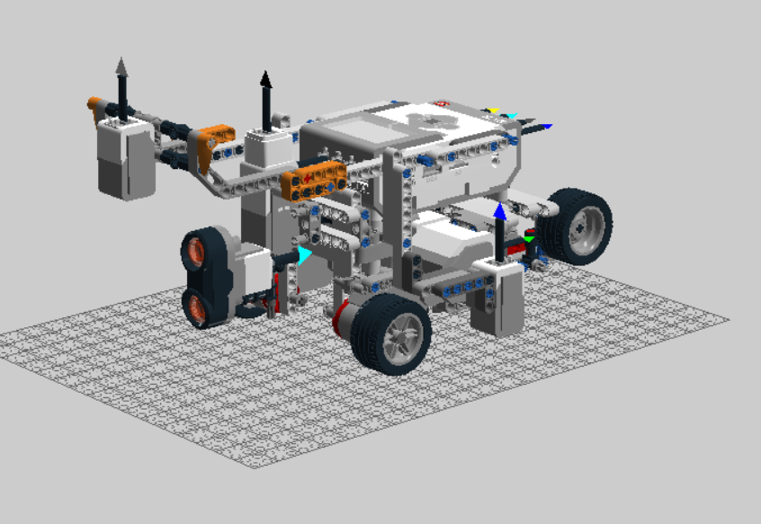 **Full Design**

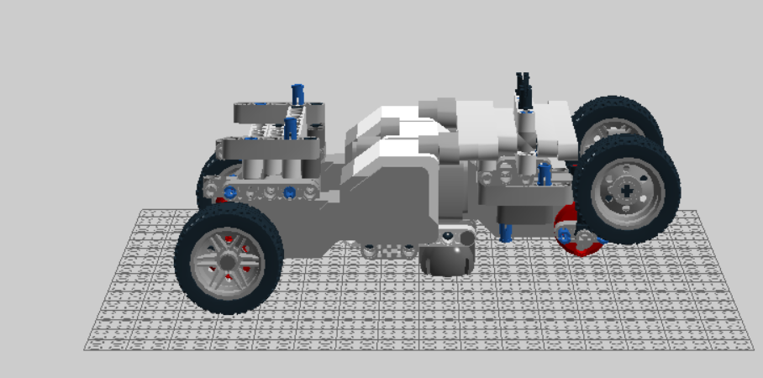 Landing Gear Component

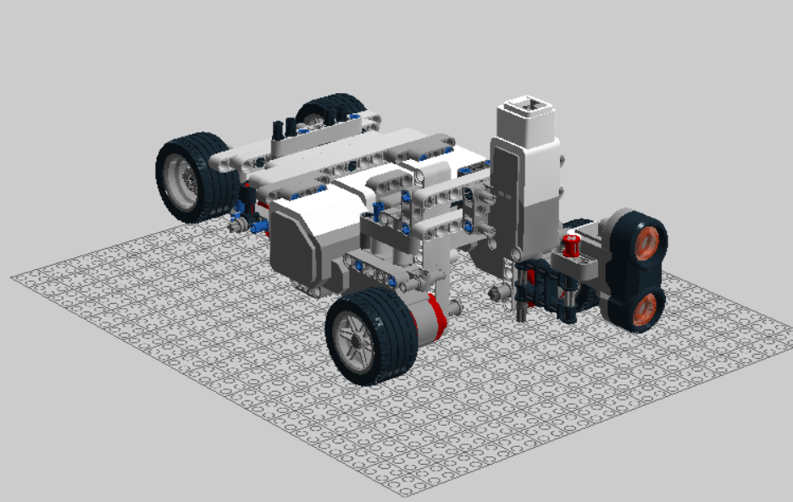 Ultrasonic Sensor Component

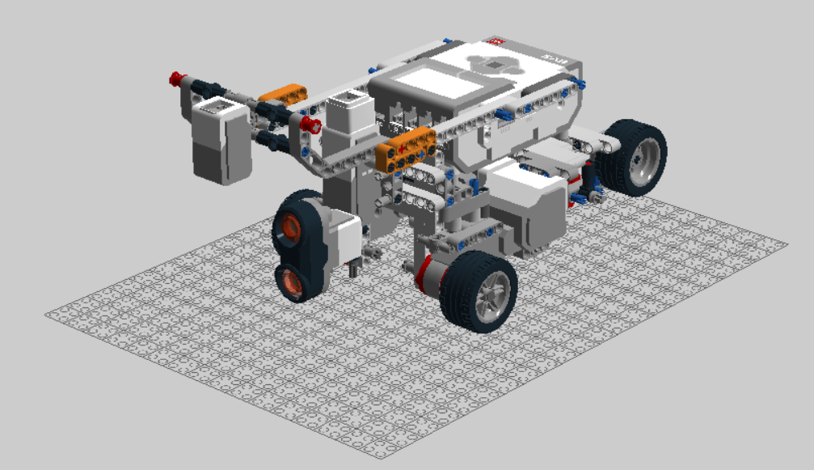- Light sensor

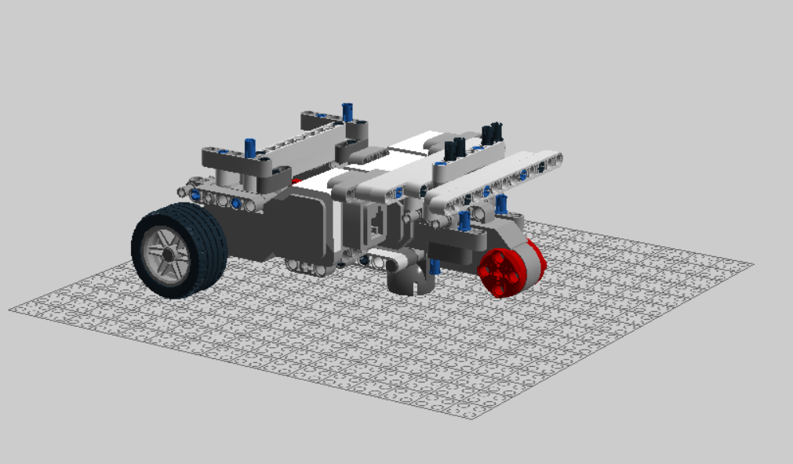 Chassis Feature

*Components Used:*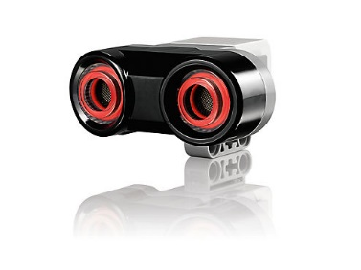 x2  
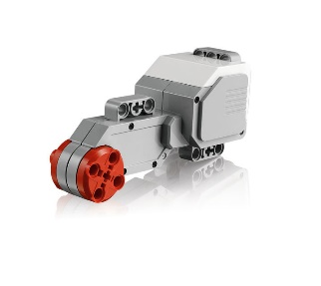x4

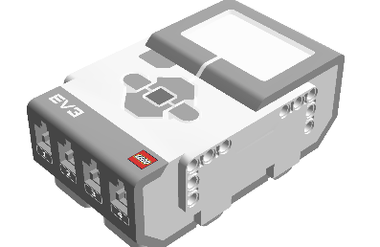 x1

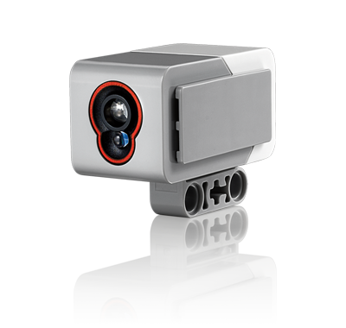 x2

**Key Design Features**

*Highlights: Variable rear wheel Landing Gear System*

* Two real wheels are ejected to support bridge traversal
* Stored back into position after traversal
  + Unique design that adds excellent stability

Solid Chassis:

* Large and Solid Chassis ensures weight distribution
* Easy access to brick’s ports and batteries

**Tools Used –**

**Slack**



**Eclipse**



**LDD**

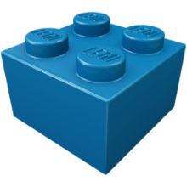

**Excel/Word/PowerPoint**







**Gantt Project**



**GitHub**



**Lego**



**Dropbox**



**Drive**



**Software-**

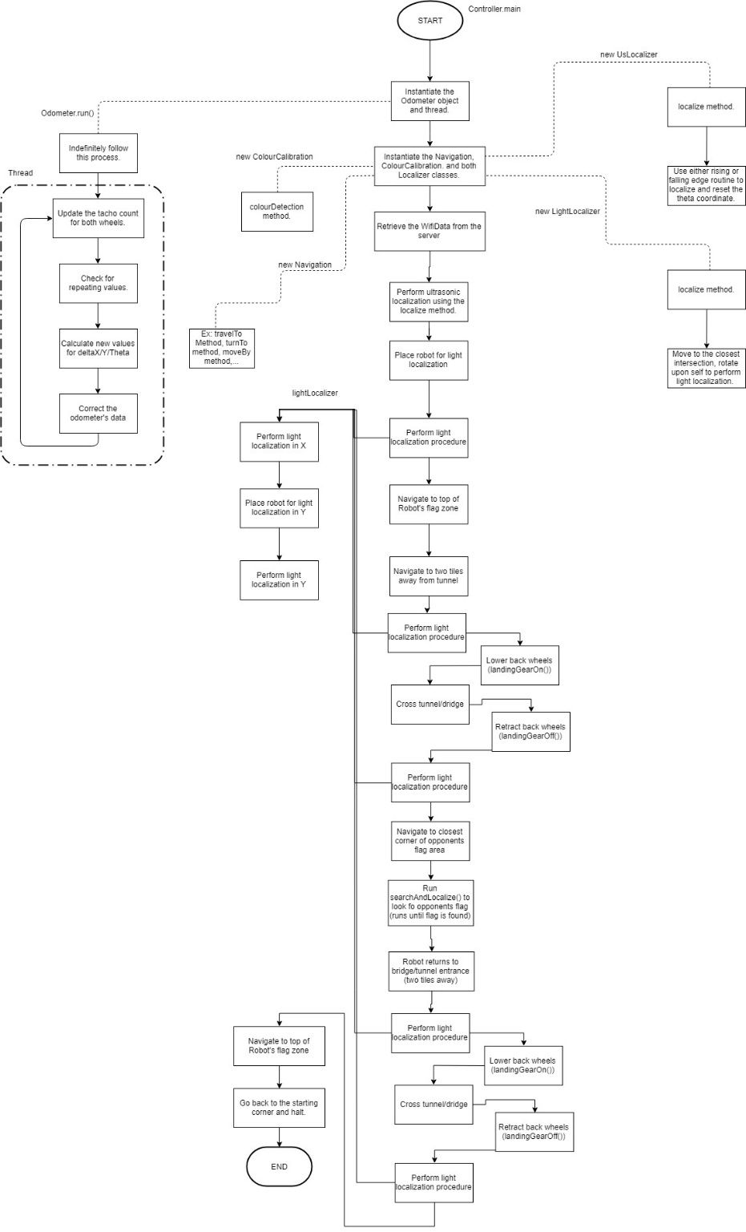

*Software Flowchart*

**Roles**Bryan Jay- Project Manager  
Luka Jurisic- Documentation Manager  
Volen Mihaylov- Software Lead  
Enan Ashaduzzaman – Hardware Lead  
Tianyi Zou- Testing Lead  
Patrick Ghazal – multidisciplinary Engineer

**Budget**

Total Budget- 351  
*Project Management-   
Hardware-   
Software –   
Testing -   
Documentation*-

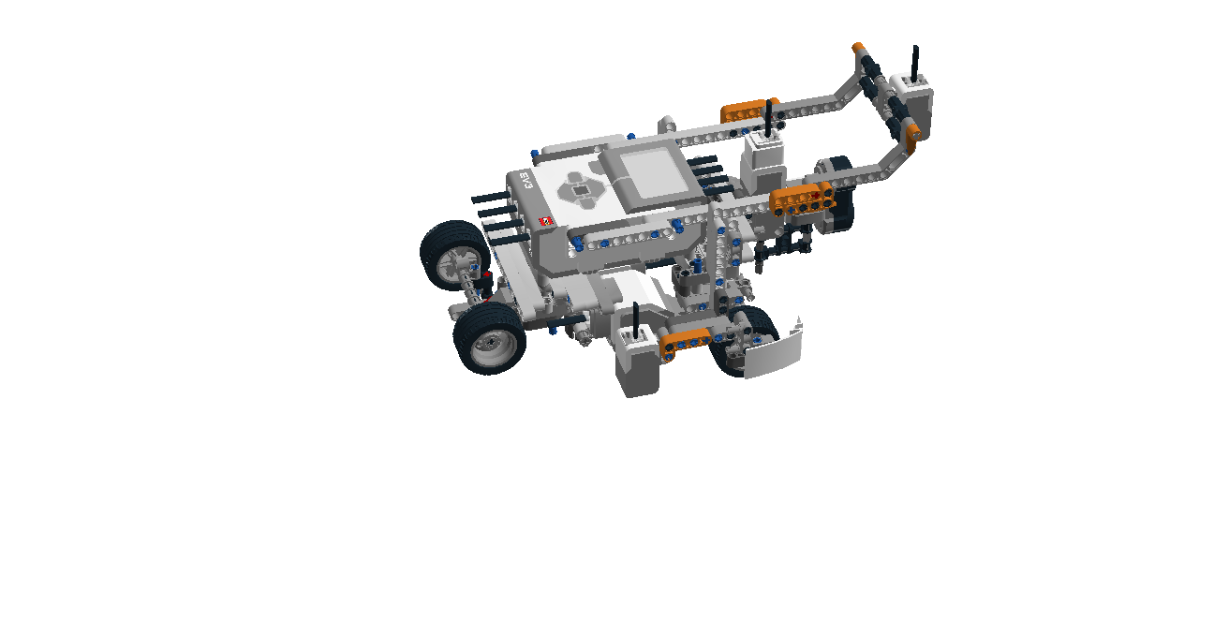

**Testing Phase**

Phase 1- Hardware Components

* Ultrasonic Sensor
* Light Sensor
* Wheel and Track optimization

Phase 2- Software Components

* Localization
* Variable Back Wheel Functionality
* Navigation and Traversal
* Searching
* Capture

Phase 3- System Integration

* WiFi Integration
* Complete System Component Integration

**Design Process**  
*Research*

* Component reuse from development
* Understanding Client Requirements
* Preliminary Designs

*Building Process*

* Hardware Prototypes
* Software Architecture
* Testing Plan

*Testing and Implementation*

* Final Design Implementation
* Modular Testing technique
* API development

*Optimization and Integration*

* Integration of Hardware and Software
* Perfection of Software
* Presentation preparation

**Test Results and Potential Improvement**  
*Landing Gear*

* Traversal Stability
* Design Niche
* Superior Weight Distribution

*Navigation*

* Excellent Precision
* *Odometer exhibits high accuracy*

